# Taxation System of India

Parth Takkar

1740246

3CMS

|  |  |  |
| --- | --- | --- |
|  |  |  |

Tax is an obligatory contribution to the state revenue; the government of India levies on the income of the workers and business gains or added up to the cost of some transactions, goods and service. The government levies taxes on the citizens of the country to produce income for business projects to enhance the country’s economy and to lift up the standard of livings of the nationals. The **Tax structure in India** is a three-tier federal structure. The central government, state governments, and local municipal bodies make up this structure. Article 256 of the constitution states that “No tax shall be levied or collected except by the authority of law”. Hence, each and every tax that is collected needs to backed by an accompanying law.

**Types of Taxes in India**

The Indian**tax structure** allows for two types of taxes—Direct and Indirect Tax.

**Direct Tax:**

It is levied directly on individuals and corporate entities. This tax cannot be transferred or borne by anybody else. Examples of direct tax include income tax, wealth tax, gift tax, capital gains tax.

Income tax is the most popular tax within this section. Levied on individuals on the income earned with different tax slabs for income levels. The term ‘individuals’ includes individuals, Hindu Undivided Family (HUF), Company, firm, Co-operative Societies, Trusts.

**New Tax slab of Income tax for FY 2017-2018(AY 2018-2019)**

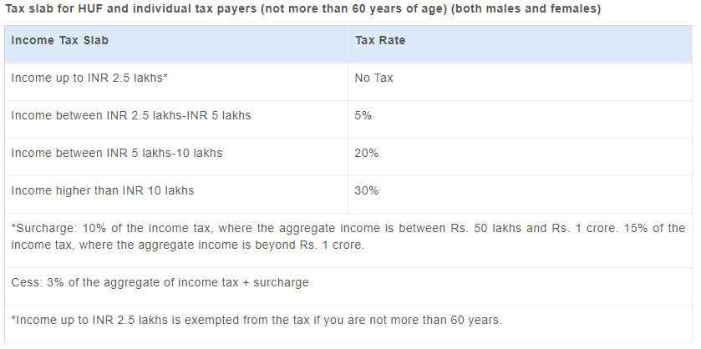

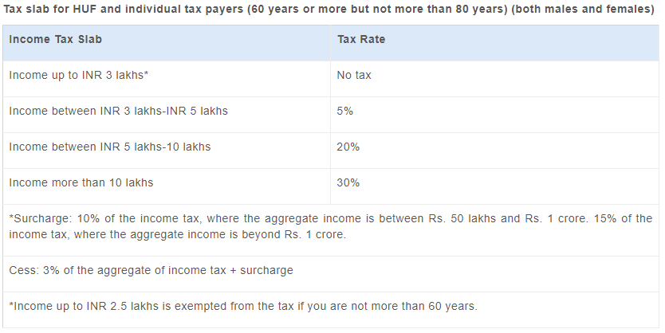

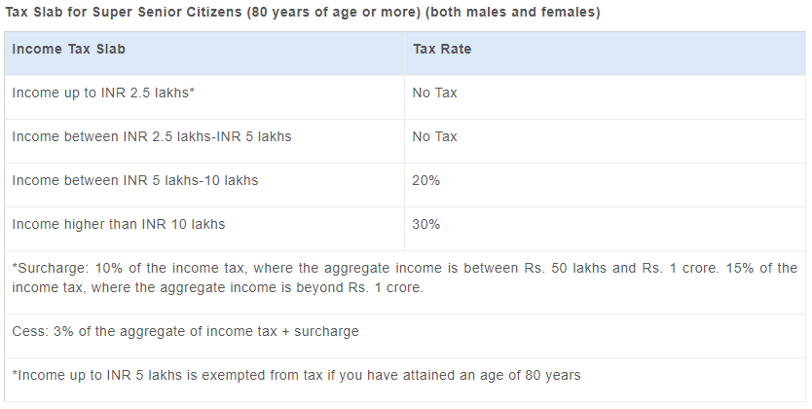

**Indirect Tax:**

These are [taxes which are indirectly levied](https://www.aegonlife.com/blog/yes-your-money-will-be-affected-by-gst-too/)on the public through goods and services. The sellers of the goods and services collect the tax which is then collected by the government bodies.

**Examples of indirect taxes are**

* **Value Added Tax (VAT)**– A sales tax levied on goods sold in the state. The rate depends on the government.
* **Octroi Tax**– Levied on goods which move from one state to another. The rates depend on the state governments.
* **Service Tax**– Government levies the tax on service providers.
* **Customs Duty**– It is a tax levied on anything which is imported into India from a foreign nation.

### Tax Collection Bodies:

The three bodies which collect the **taxes in India** have clearly defined the rules on what type of taxes they are permitted to collect.

* **The Central Government:** income tax, custom duties, central excise duty.
* **The State Governments:** tax on agricultural income, professional tax, value- added tax, state excise duty, stamp duty.
* **Local Bodies:** property tax, water tax, other taxes on drainage and small services.

### GST:

In India, the three government bodies collected **direct and indirect taxes** until 1 July 2017 when the Goods and Services Act (GST) was implemented. GST incorporates many of the indirect taxes levied by states and the central government.

Some of the taxes GST replaced include:

* **Sales Tax**
* **Central Excise Duty**
* **Entertainment Tax**
* **Octroi**
* **Service Tax**
* **Purchase Tax**

It is a multi-stage destination-based tax. Multi-stage because it is levied on each stage of the supply chain right from purchase of raw material to the sale of the finished product to the end consumer whenever there is value addition and each transfer of ownership.

Destination-based because the final purchase is the place whose government can collect GST. If a fridge is manufactured in Delhi but sold in Mumbai, the Maharashtra government collects GST.

A major benefit is the simplification of **taxation in India** for government bodies.

GST has three components:

* **CGST-** Stands for **Central Goods and Services Act**. The central government collects this tax on an intrastate supply of goods or services.  
  (Within Maharashtra)
* **SGST:** Stands for **State Goods and Services Tax**. The state government collects this tax on an intrastate supply of goods or services.  
  (Within Maharashtra)
* **IGST:** Stands for **Integrated Goods and Services Tax**. The central government collects this for inter-state sale of goods or services.

(Maharashtra to Karnataka)

### Other Government Bodies:

For a smooth implementation of the **Indian tax system**, there are bodies dedicated to it. Popularly known as the revenue authorities.

* **CBDT:** The Central Board of Direct Taxes is a part of the revenue department under the Ministry of Finance. It has a two-fold role. One, it provides important ideas and inputs for planning and policy with regard to direct tax in India. Second, it assists the Income Tax department in the administration of direct taxes.
* **CBEC:** The Central Board of Excise and Customs deals with policy formulation with regard to levy and collection of customs and central excise duties and service tax.
* **CBIC:** Post GST implementation, the CBEC has been renamed as the Central Board of Indirect Taxes & Customs (CBIC). The main role of CBIC is assisting the government in policy-making matters related to GST.

The **tax system in India** for long was a complex one considering the length and breadth of India. It is hoped that post GST implementation, the process becomes smoother.